2019 Fall Youth Garden Educator Training
September 14th 2019
San Antonio Botanical Garden
555 Funston Rd. San Antonio TX 78229

Check in: 8:30am-9:00am

Time | Main Classroom |  | CVG Outside White Tent |  | Greenhouses and Auld House |  | Garden
 | Speaker | Content | Speaker | Content | Speaker | Content | Speaker | Content
9:00am-9:30am | Ruby Zavala, Youth Gardens Coordinator | Classroom Gardens Program | All in Main Classroom |  | All in Main Classroom |  | All in Main Classroom
9:40am – 10:40am | Henry Brune, Bexar County Master Gardener | Beginner Class: Raised Beds and Site Selection | Bill Swantner, Bexar County Master Gardener | Advanced Class: 7 Habits of a Successful Gardener | JD Sites, KBW Supply  (Greenhouses) | Greenhouse Maintenance | Grace Emery, Bexar County Master Gardener | Culinary Garden Walking Tour
10:50am –  11:50am | Margaret Bass, Ag Youth Outreach | Elementary Grade Level Garden Lessons | Mary Helen Phillips, Comal County Master Gardener, Youth Ed | Early Childhood Garden Lessons ages 3-6 | Rudy Ruedas, 4H Youth Educator  (Auld House) | Middle School to High School: Cooking with Your Harvest | Susan Porr, Bexar County Master Gardener | Children’s Walking Garden Tour
11:50am –  12:30pm | Lunch |  | All in Main Classroom |  | All in Main Classroom |  | All in Main Classroom
12:30pm –  1:30pm | Q&A Discussion w/ David Rodriguez, Bexar CEA-Horticulture |  | All in Main Classroom |  | All in Main Classroom |  | All in Main Classroom
1:30pm –  2:00pm | Evaluation/Certificate  Plant Pick up |  | All in Main Classroom |  | All in Main Classroom |  | All in Main Classroom

Texas A&M AgriLife Extension provides equal opportunities in its programs and employment to all persons, regardless of race, color, sex, religion, national origin, disability, age, genetic information, veteran status, sexual orientation, or gender identity.
The Texas A&M University System, U.S. Department of Agriculture, and the County Commissioners Courts of Texas Cooperating
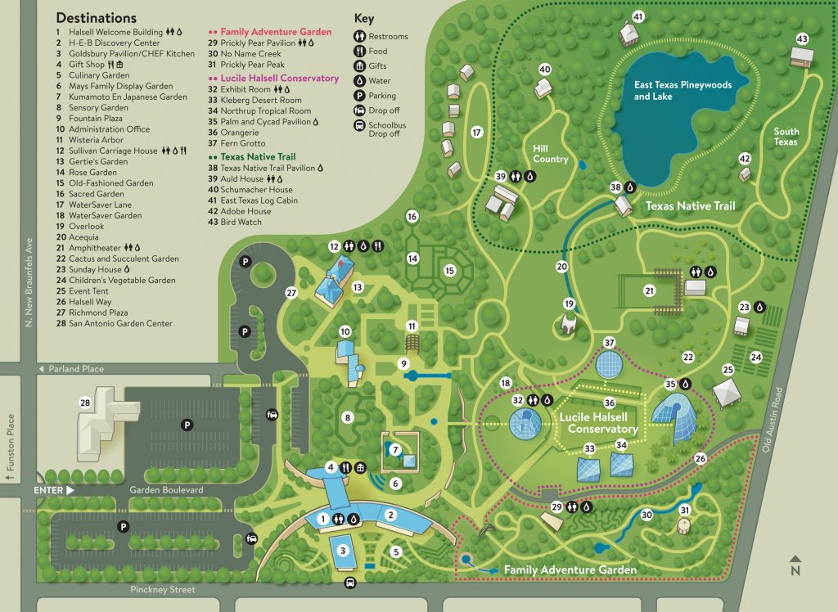
Culinary Garden
CVG
Greenhouses
Auld House
Outside Tent at CVG
Main Classroom
Entrance
Exit
Plant Pick Up

