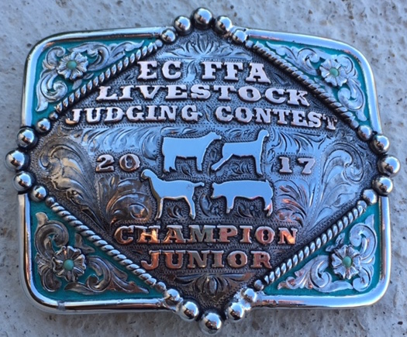
East Central FFA
Booster Club:
Livestock Judging Contest

Date: Saturday February 25, 2017 (the day before the San Antonio contest)
Time: Check-in, 1:30 to 2:30, contest will begin at 2:30
Cost: $10.00 per individual if pre-registered through judgingcard.com
$15.00 per individual on-site registration (payable through judgingcard.com)
Location: East Central FFA Show Barn
7173 FM 1628, San Antonio TX (15 min. from the S.A.L.E. grounds)

Possible classes will include: 2-3 hog classes
2-3 sheep classes
2-3 goat classes
2 cattle classes
3-4 question classes

3 age divisions: Pee Wee—8 & under (as of January 1, 2017)
Junior—14 & under (as of January 1, 2017)
Senior—15 & up (as of January 1, 2017)

Awards sponsored by Jeff Schroeder of
Livestock Judging.com & Cattle.com

The high individual in the Pee Wee, Junior, and Senior divisions will receive a belt buckle, 2nd through 20 individuals will also receive awards. Pee Wee, Jr., & Sr. top individuals 5 in cattle, hogs, sheep, goats, and questions

Bring your own scantrons (Universal “A”)
If you need further information you can contact: Danny Kempen, 210-279-7742

